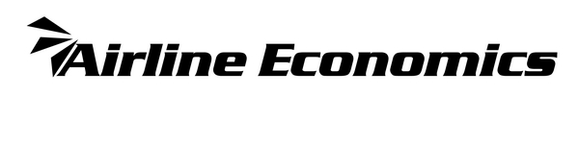
Airline Economics
Aviation 100 Middle East & Africa
& Islamic Finance Awards 2023
NOMINATION ENTRY FORM

AIRLINE ECONOMICS AVIATION 100 Middle East & Africa & Islamic Finance AWARD CATEGORIES

Airline of the Year
These awards will be based primarily on the results of the industry survey – use this link to vote:
https://www.research.net/r/MEA2023
Voting closes on 10th September 2023.

Lessor of the Year
Bank of the Year
MRO of the Year
Law Firm of the Year
CEO/Industry leader of the Year
CFO/Treasurer of the Year

DEALS OF THE YEAR AWARDS CATEGORIES FOR 2023 OPEN FOR NOMINATION
Middle East & Africa Editor’s Deal of the Year
Middle East & Africa Lease Deal of the Year
Middle East & Africa Debt Deal of the Year
Middle East & Africa Islamic Finance Deal of the Year
Middle East & Africa Equity Deal of the Year
Middle East & Africa Supported Finance Deal of the Year
Middle East & Africa Structured Finance Deal of the Year
Middle East & Africa Overall Deal of the Year

Please submit one nomination for each transaction, clearly noting which category you are entering, and return it to Victoria Tozer-Pennington victoria@aviationnews-online.com by 9th September 2023.

Bank of the Year and Law Firm of the Year are also open for nomination as well as the online industry survey, please submit all relevant deals closed during YTD2023 year-to-date in support of your nomination as well as a 200-word abstract on why your firm deserves to win.

ENTRANTS CONTACT INFORMATION
Company name:
Main contact for this nomination:
E‐mail address:
Telephone:

NOMINATION DETAILS
Award category:
Deal name:
Deal value:
Banks involved and their roles:
Other companies and clients involved and their roles:

Structure (please be detailed and specific):
Country/region of client:
Closure date of the deal:

Please include as much information about the deal here, including highlighting its key successes, innovations and any challenges/difficulties that were overcome, and why this transaction deserves to win.

